- Once user clicks on follow-up while booking an appointment – the “followup” fees should be reflected and not the consultation fee for an doctor (currently even after selecting followup – it shows the consulation fees only)
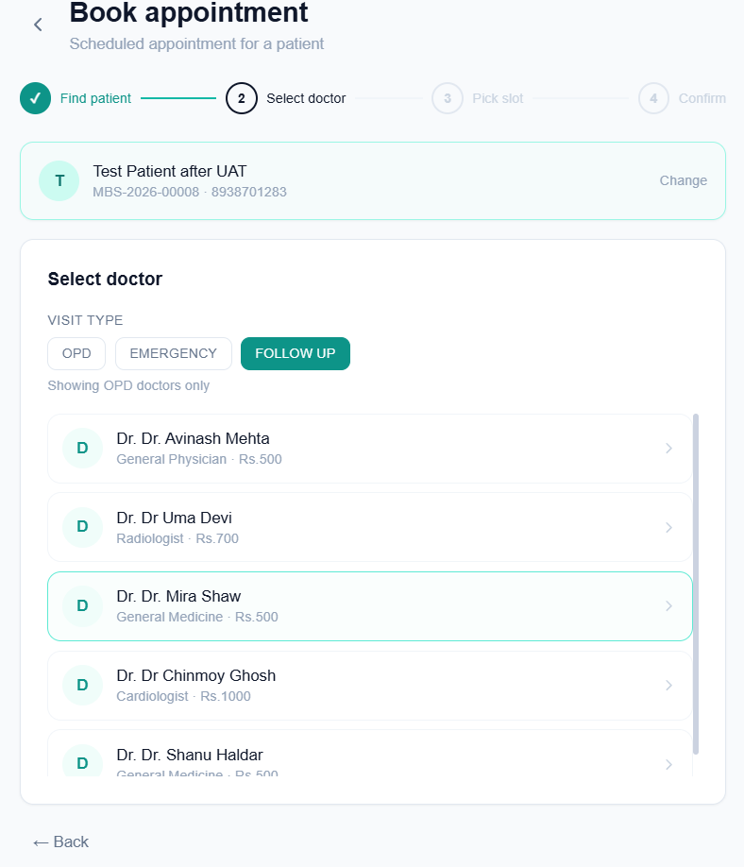
- While adding a doctor from the settings page of admin – the options comes as OPD; Emergency; IPD and Both (OPD+Emergency+IPD). We should remove the “Both” option and allow multiple selection – so that user can select one or more of the 3 options (OPD/IPD/Emergency). MOST Importantly – this option should also be available from the doctors page – when a user clicks on “Add Doctor” – it should also have the option to select “department type”
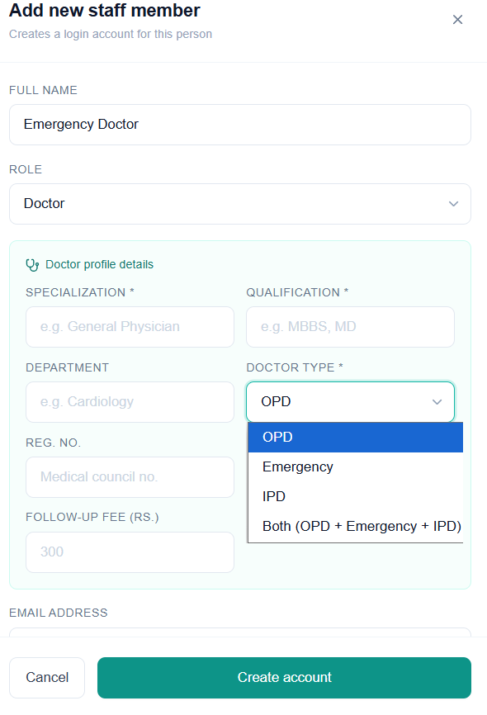
- Encountering “Unexpected error occurred” while trying to add a doctor from admin settings page
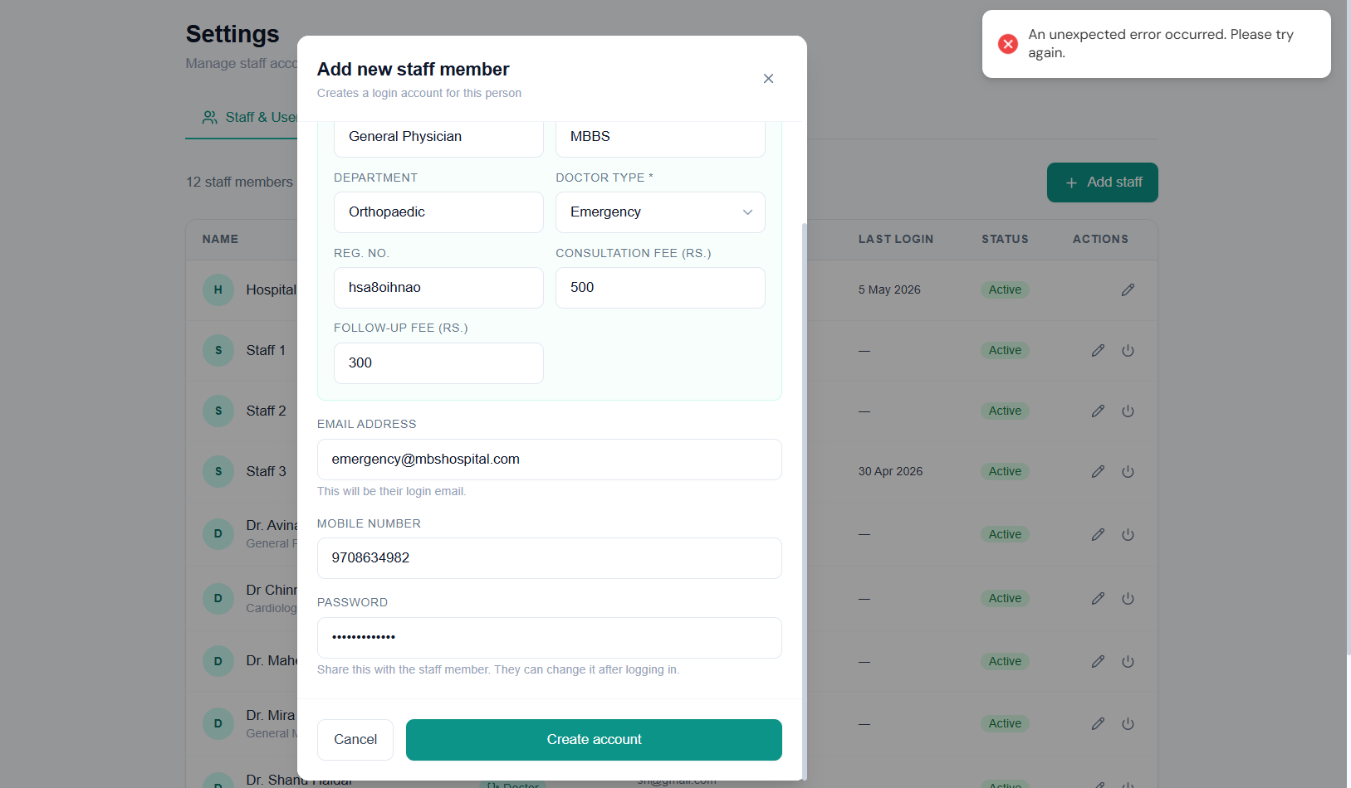
- Doctor not getting saved even from the “Doctors” page -> “Add new Doctor”. Even after adding specialization, error appears while trying to save – “Specialization needed”
